# Proposal for Project

# Group B (BSHC3B, BSHTM3)

|  |  |
| --- | --- |
| **Project title:** | Events for OAP (Golden Years) |
| **Group:** | B |
| **Project manager:** | Varies per week |
| **Team members:** | Charlene Moore, Keith Feeney, Jessica Bankole and Angela Darel |

Contents

Overview 3

Target group 3

Market Analysis 3

Functionality 4

Payment system: 5

Accessibility: 5

Tracking: 5

Medical Support: 5

Golden Year University: 5

Mock-up 5

Project Plan 7

Members: 8

Project Plan: 9

Summary 10

References 11

# Overview

“Golden Years” is a web based application. It will be created to help OAPs find and participate in events, specifically in Ireland. This Project is a learning experience as there's little knowledge on this topic within the group regarding the technology and functionality. On completion of this project, users of Golden Years will be able to find the events they’re interested in, book events of their choice, pay for them (optional) and plan how to get to said event. The application should be able to make money by selling the events, transport and advertising space to partners.

# Target group

The main target audience of this Project is for old-age pensioners. Many OAPs spend their time relaxing or watching television (Brandon, 2013). There’s not much to do regarding events within Ireland for OAPs. Age Action Ireland offers some events, but more orientated for the likes of government voting and for “empower[ment]”. (Age Action Ireland, 2016)

This Project is for the likes of these OAPs, who want to go out dancing, volunteering or local activities and events near them. The group found that it was difficult to find events for OAPs in Ireland by doing the likes of Google searches.

“Golden Years” is being created for this purpose. The group is creating a Web Application where users can book and pay for events. The idea is that kiosks would be placed around cities and towns so that when people are out and about, they could book an event there and then.

Even though the application is for OAPs, the likes of their family or friends could also book events for them too. Everyone would be able to use it.

# Market Analysis

The group’s original idea was to just create a Web Application for events, with no specific target audience. However, there are plenty of these already available, for example Ticketmaster and Creative Events. Regarding these websites, if one is not a small bit computer literate, they can be cumbersome. OAPs generally don’t have enough knowledge on computers to be able to use these sites.

With discussion with the group, it was decided that there was not anything for the older people and specifically for OAPs. The Project will differ from the likes of the sites above by being simple and easy to use that anyone could use it.

Regarding Ticketmaster’s homepage, there is so many things to click with a scrolling inline advert at the top. Even as people who understand computing, the group found it difficult to navigate to an event one is interested in. It’s very complex and cluttered. (Ticketmaster, 2017) The group decided that this was far too complex and cluttered to use in the Web Application.

Creative Events’ website is far less cluttered than Ticketmaster’s. But it’s still not entirely simplistic. The website has 3 events per row with multiple columns. Each event has a title and a little description about the event. (creativeevents.ie, 2017) As a Group we like how the events were displayed in this way and will be implanting something similar into the Web Application.

# Functionality

The main function of the Web Application is to book an event. Users will be given the option to sign up/log in or continue as a guest as having an account is not required. Every part of the app is accessible by both types of user. If the user signs up/logs in, their name and ID number will be displayed. If the user is a guest a “Do you wish to sign up?” message will replace a user’s name and ID number. A confirmation email will be sent to their personal email for verification. Members and visitors are able to see previous events, book an event, search for new events. Members only are able to save to wish list or email to their personal email or share to friends, straight from the Web Application. When booking, the logged in user will not need to input their personal information, while a guest will have to.

**Some key features of the app;**

Payment system: The payment system will enable the credit cards to be processed. New visitors and members can pay for an event on arrival at the event. The card processing allows cards to be verified. The receipt can be printed or send to personal email address. The app will have encryption for the payment of booking the fee's.

Accessibility: Users will be able to access the web applet from their smart phones, tablets and on pc. Unfortunately, user’s will not be able to access the web applet offline, Wi-Fi is required.

Tracking: The Web Application will know where it is via the likes of GPS. This is useful for future developments of the app.

Medical Support:Member who are registered will only be entitle to medical support at the event in case of any emergency

Golden Year University: Golden Year University will offer members online short courses such as, learning how to use computer, how to use a smart phone and how to reply to emails and booking a flight, for example.

The Web Application will be able to store any information the user inputs into the system and store it in the database. We aim to keep our applet simple and convenient to use. Our main aim is that events for elderly people will be booked easy and efficiently without any stress. The application will have Google Maps integrated showing the events of the area on this map. The application will allow users to create an account or continue as a user. By creating an account, the likes of special offers could be sent to the user.

# Mock-up

To create wireframe, we've used Paint. As our project aims for elderly people, it needs to be as simple visually as possible and easy to use.

**Page Mock ups:**

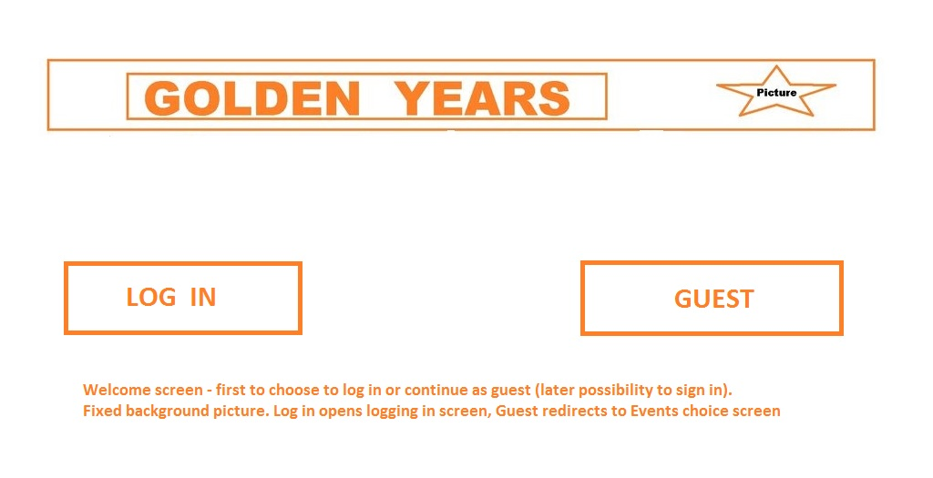

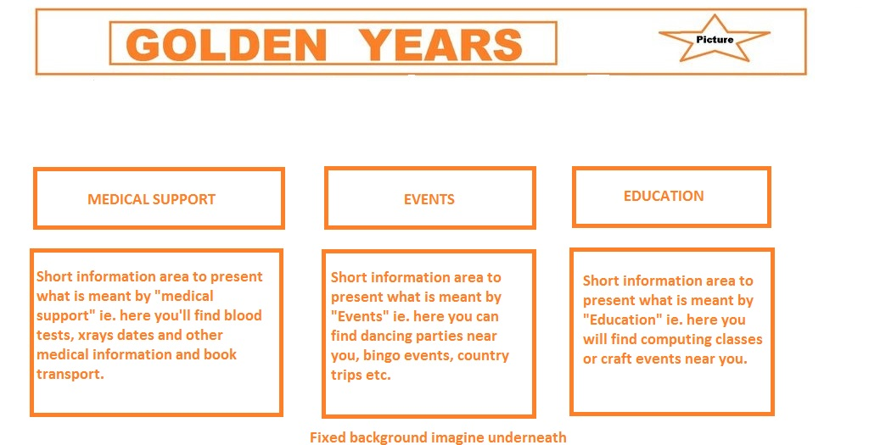

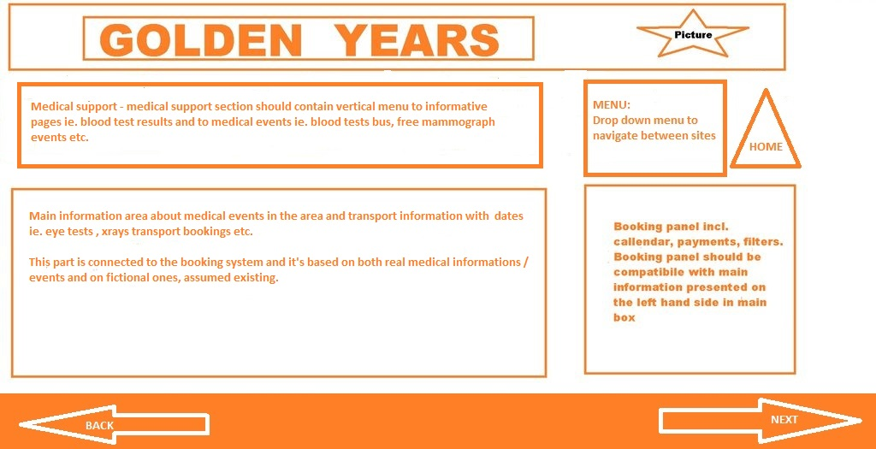

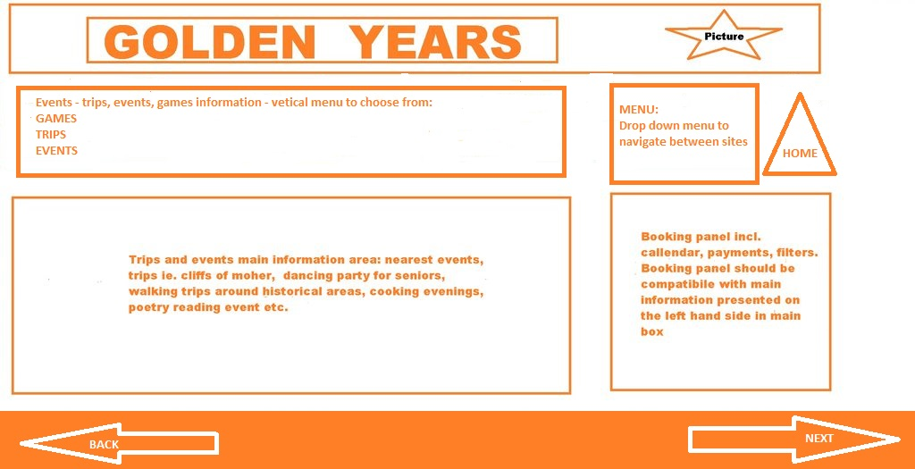

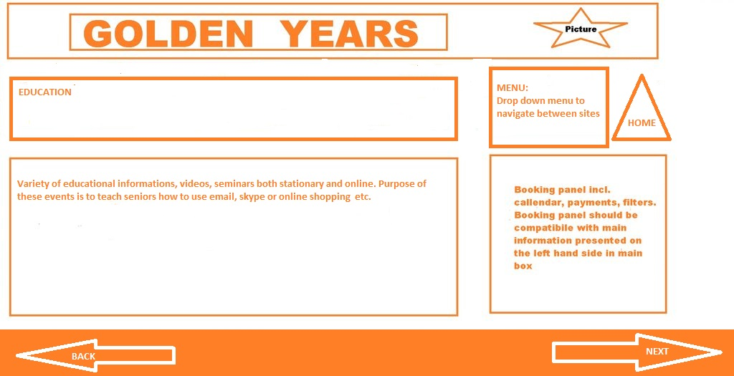

(Created with Microsoft Paint)

# Project Plan

We plan to have a weekly meeting on Mondays to go over what was done the previous week and to discuss what tasks need to be done for the current week. Any issues can be resolved at this time. As we have no lectures Wednesday, additional work will be completed then.

Deadlines:

* Week 2 – Project Proposal
* Week 4 – Requirements Specifications
* Week 5 – Research on given part of the project, view/test samples
* Week 6 – Begin Implementing code
* Week 7 – Test code with other aspects of the applet.
* Week 8 – Midpoint presentation / Review feedback
* Week 9 – Research (if needed) to incorporate feedback, view/test samples
* Week 11 – Implement coding
* Week 12 – Finalise applet / Technical Report
* Week 13 – Final presentation (video)

## Members:

**Angela** is very good at talking and selling a point. The group felt it was best for her to create the Mock-ups in this report. Angela has been given the Web Applet (a basic version) as this would be new for her.

**Charlene** is very good at summarising and providing and overview, as well as selling a point. The group decided that Charlene should do the Login system as this was new to her.

**Jessica** is very hands-on and has a good understanding of how payments would work. The Group decided that she would benefit doing the Credit Card/Payment system.

**Keith** is the coder in the group. As Keith is good with understanding coding and getting them to work, the Group decided that Keith should do the Databases.

## Project Plan:

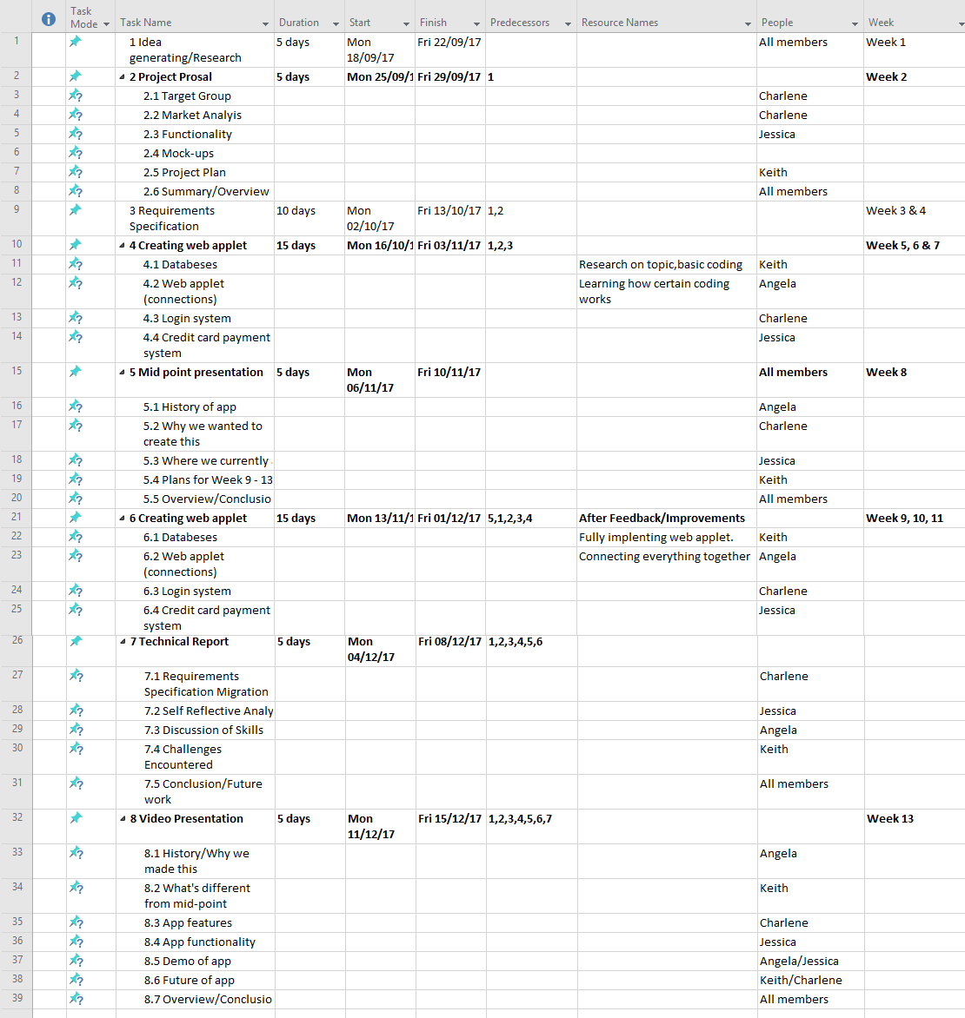

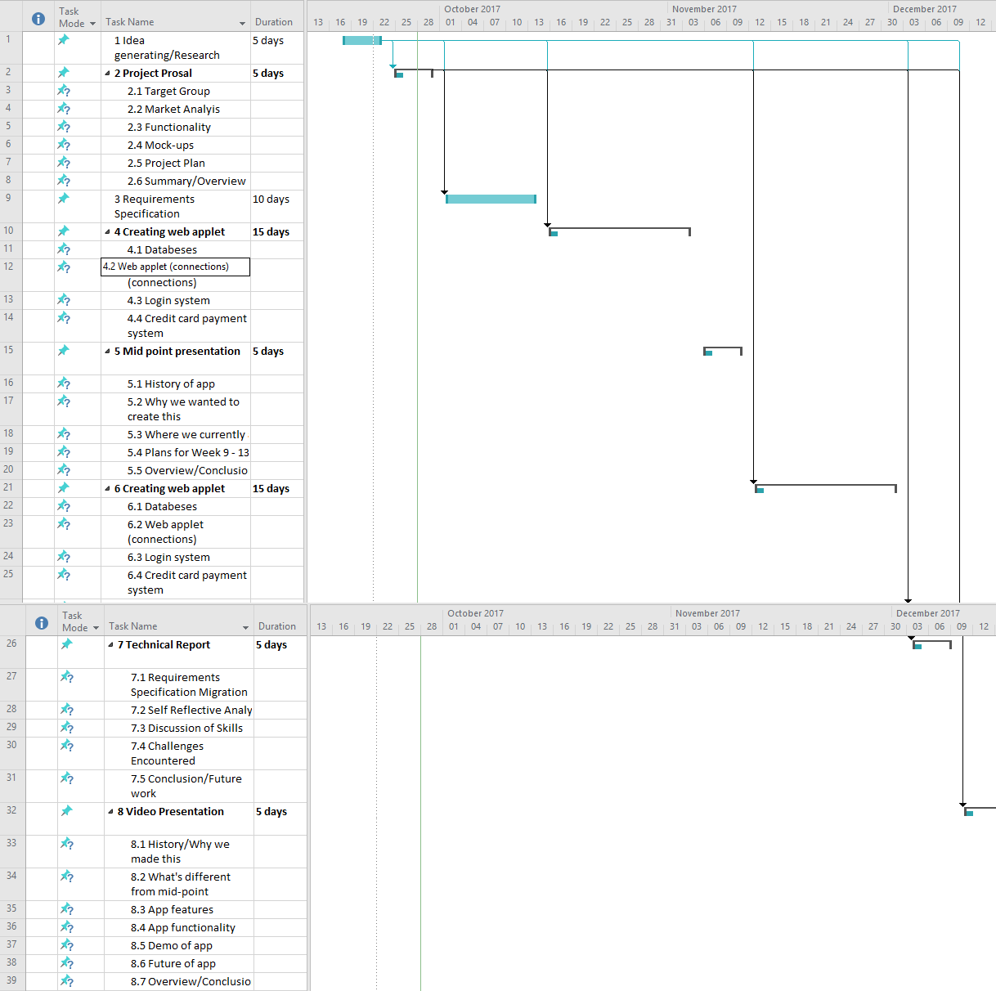

**Gan**[**tt Project Link**](https://studentncirl-my.sharepoint.com/personal/x15015556_student_ncirl_ie/_layouts/15/guestaccess.aspx?docid=04f664063586d44749a0374239e38c9de&authkey=AdCDGP6t-dqoyD4ALIh3Ewg&expiration=2018-09-29T13%3a24%3a27.000Z)

# Summary

The Project will be a Web Application. The Proposal discusses how it will be created for OAPS. The main aim is to help assist them in finding events for them to go to. It also discussed how that there isn’t much currently available to do for the OAPs. When this Project is completed, the user will be able to find, book and pay for events though the application. The application will earn revenue by getting companies that hold events to become partners and have their event(s) added to the application.

# References

Age Action Ireland, 2016. *Our Vision.* [Online]   
Available at: https://www.ageaction.ie/about-us/our-vision-and-mission  
[Accessed 29 September 2017].

Brandon, E., 2013. *How Retirees Spend Their Time.* [Online]   
Available at: https://money.usnews.com/money/retirement/articles/2013/07/08/how-retirees-spend-their-time  
[Accessed 29 September 2017].

creativeevents.ie, 2017. *creativeevents.ie.* [Online]   
Available at: https://www.creativeevents.ie/  
[Accessed 29 September 2017].

Ticketmaster, 2017. *Ticketmaster.* [Online]   
Available at: http://www.ticketmaster.ie/  
[Accessed 29 September 2017].